Instructions and Template for Abstract Submission

- Authorª*, B. Author^{b}.,....

ª Name of the organisation of author A, Address
^{b} Name of the organisation of author B, Address

*corresponding author e-mail

Communications regarding the conference will be sent to the corresponding author.

General participation rules
This file provides guidelines for submitting abstracts for oral or poster presentation. The text is itself an example of the layout and style required for the 2-page (maximum) abstract that will be published in the book of abstracts. Abstracts are expected to be in English.

Word file preparation
Documents must be submitted as a Microsoft Word file to e-mail: abstracts@ pmea.eu
The deadline for abstract submission is 15.01.2026.
After acceptance of the abstract, payment of the conference fee must be performed by 15.02.2026.
Carefully check the contents and format of your abstract before submitting it (it will appear in the published document in exactly the same form).

Tables and Figures (optional)
Tables and figures should have a caption and be centre-justified. All lettering should be 10-point-bold type. Figures must not extend into the margins.

Text format
The title should be in boldface letters centred across the top of the first page using 12-point type. First letter capitals only for the title. Insert a blank line after the title, followed by Author Name(s) – centred, in 12-point non-bold type and Affiliation(s) – centred, in 10-point non-bold type.

Times New Roman is the recommended typeface for all the text (main text, section and subsection headings, caption, etc.) using 10-point type. The type size for all text has to be 10-point. Single (1.0) line spacing is recommended. Do not put numbers, running footers or headers on pages.

Acknowledgements

References
References should be collected at the end of the abstract. When referring to them in the text, type the corresponding reference number in square brackets, as in this example [1].

[1] H. Sung, Y. Wang, C. Wan, J. Elechem. Soc. 145 (1998) 1207-1211.
[2] H. Strehlow, Electrode Potentials in Non-aqueous Solvents in The Chemistry of Non-aqueous Solvents, Vol. 1 (Legowski J. J., ed.). Academic Press, New York 166, page 157.

MAXIMUM LENGTH
OF THE ABSTRACT IS 2 PAGES

AN EXAMPLE OF A SPECIFIC ABSTRACT IS PROVIDED BELOW

Synthesis of MOF@HPCM Composites

T. Zelenkaª, M. Almáši^{b}*

ª Department of Chemistry, Faculty of Science, University of Ostrava, 30. Dubna 22, 702 00 Ostrava, Czech Republic
^{b} Department of Inorganic Chemistry, Institute of Chemistry, Faculty of Science, Pavol Jozef Šafárik University in Košice, Moyzesova 11, 040 01 Košice, Slovak Republic

*miroslav.almasi@upjs.sk

Metal–organic frameworks (MOFs), assembled by metal ions or their clusters and organic linkers, are one of state-of-the-art crystalline materials. Their features such as ultra-high porosity, synthetic tailorability, and relative ease of synthesis make them promising candidates for diversified applications. Controllable integration of MOFs and carbon-based materials not only leads to further enhancement of single-phase MOFs in terms of stability and gas adsorption properties but also surprisingly brings about a number of new functionalities like the formation of new pores and template effects. These benefits allow the resultant MOF–carbon composites to be applied beyond the fields of single-phase MOFs. Increasing research interests have been aroused in this rapidly developing interdisciplinary area [1, 2].

In the presented study, we focused on the preparation of composite materials consisting of MOFs (metal-organic frameworks) and HPCM (hierarchically porous carbon material) compounds. The synthesis was carried out in situ, which means that the MOF crystals were formed directly in the HPCM pores during the preparation of the MOF material. Initially, a solution used for MOF synthesis was prepared into which HPCM monoliths were inserted and the reaction mixture thus prepared was heated to the required temperature (80-110°C) depending on the selected MOF (HKUST-1, UiO-66, and UiO-66-NH₂). The reactions were optimized by varying the reaction conditions such as reaction temperature, time, concentration of the initial solution, and number of HPCM monolith cubes. The results of SEM analysis confirmed the presence of MOF materials in the inner volume of the HPCM monoliths, which formed either isolated crystals (HKUST-1@HPCM, UiO-66@HPCM) or layers covering the carbon surface (UiO-66-NH₂@HPCM, see Fig. 1a). Subsequently, the prepared MOF@HPCM composites were studied by PXRD, which identified the desired MOF and confirmed the phase purity (see Fig. 1b). The prepared composites will be subsequently investigated as adsorbents of carbon dioxide, hydrogen and as adsorbents of organic pollutants and toxic metal ions from wastewater.

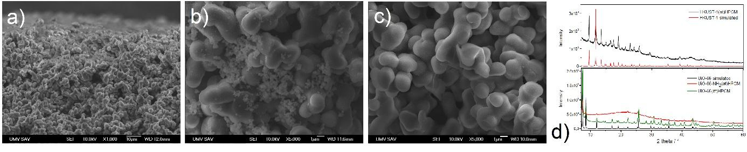
Figure 1 SEM analysis of a) HKUST-1@HPCM, b) UiO-66@HPCM, c) UiO-66-NH₂@HPCM composite materials, and b) corresponding PXRD patterns.

Acknowledgements
This work was supported by APVV project no. SK-CZ-RD-21-0068 and LUASK22049 (INTER-EXCELLENCE II, MŠMT).

References
[1] X. Liu, T. Sun, J. Hu, S. Wang, J. Mater. Chem. A, Mater. Energy Sust. 4 (2016) 3584–3616.
[2] S. Ayyagari, M. Al-Haik, Y. Ren, A. Abbott, E.B. Trigg, B. Zheng, H. Koerner, Comp. B: Eng. 224 (2021) 109197.

